Set 22: Time Series Analysis
Department | AIDS
Course Code / Course Name | DSA0602/ Data Handling and Visualization
Experiment | Data Visualization using R
Name | Ayesha Siddiqa S
Register Number | 192324305
Date | 15/10/2026
Day | Thursday

1. Time series line chart
Aim: To visualize the trend in monthly sales using a line chart in R.
Algorithm:
- Create a dataset containing months and sales.
- Load the ggplot2 library.
- Plot months on the X-axis and sales on the Y-axis.
- Add a title and axis labels.
Code:

if (!requireNamespace("ggplot2", quietly = TRUE))
install.packages("ggplot2", repos = "https://cloud.r-project.org")
library(ggplot2)

sales <- data.frame(
Month = factor(c("January", "February", "March", "April", "May"),
levels = c("January", "February", "March", "April", "May")),
Sales = c(15000, 18000, 22000, 20000, 23000)
)

write.csv(sales, "monthly_sales.csv", row.names = FALSE)

ggplot(sales, aes(x = Month, y = Sales, group = 1)) +
geom_line(color = "blue", linewidth = 1) +
geom_point(size = 3) +
labs(title = "Monthly Sales Trend",
x = "Month", y = "Sales ($)") +
theme_minimal()
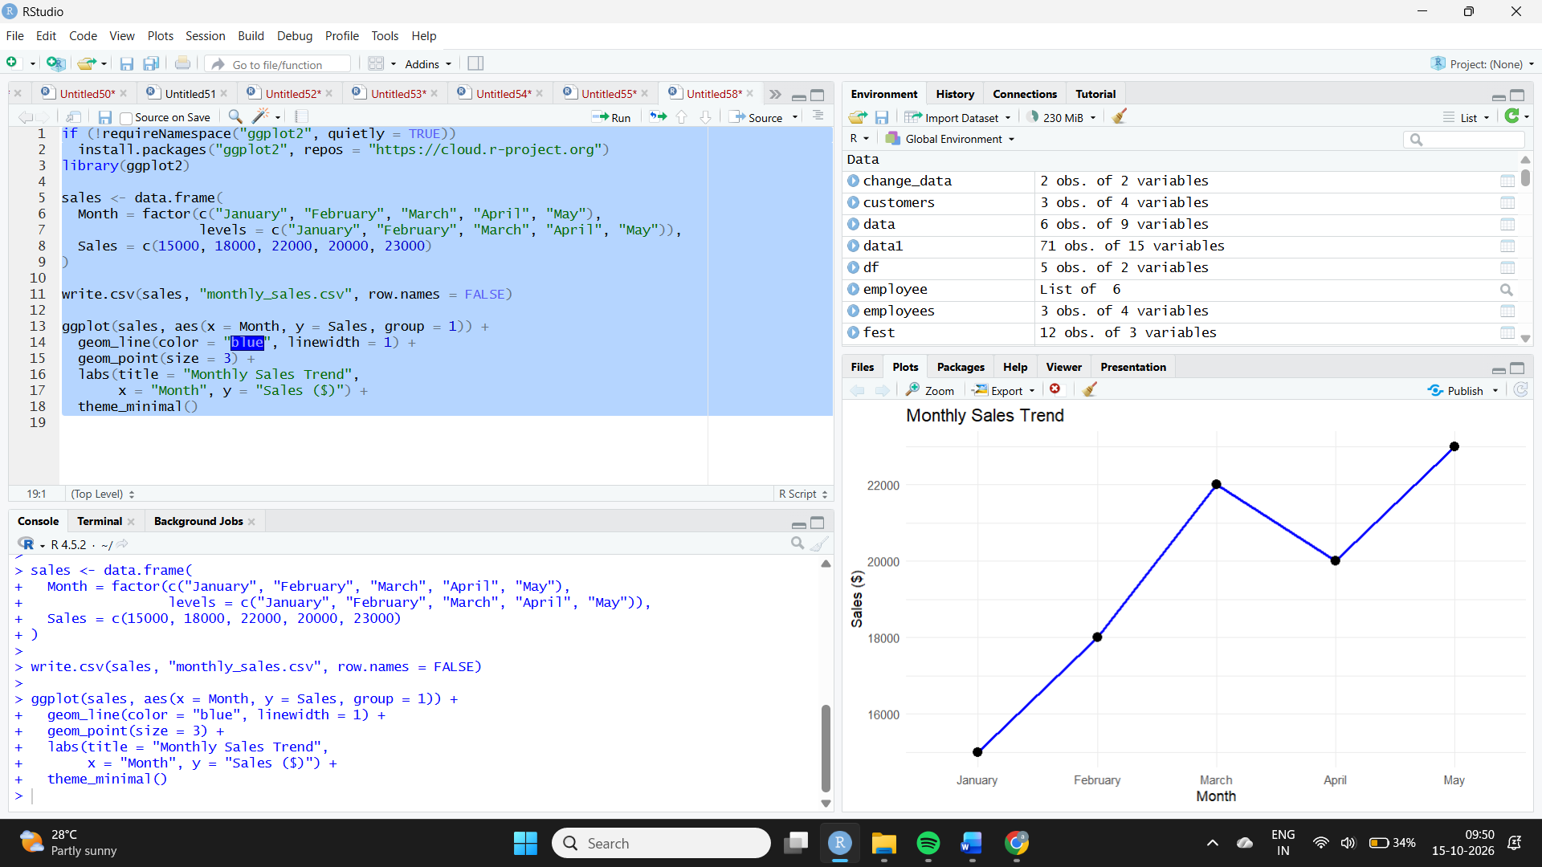
Observation: Sales increased from $15,000 in January to $23,000 in May, an overall increase of $8,000. Sales decreased from $22,000 in March to $20,000 in April before rising again.
2. Scatter plot: Advertising budget and sales
Aim: To analyze the relationship between advertising budget and monthly sales.
Algorithm:
- Create a dataset containing advertising budgets and monthly sales.
- Plot advertising budget on the X-axis and sales on the Y-axis.
- Add points and a trend line.
- Interpret the relationship.
Code:

library(ggplot2)

ad_data <- data.frame(
Month = c("January", "February", "March", "April", "May"),
Advertising = c(2000, 2500, 3200, 2800, 3500),
Sales = c(15000, 18000, 22000, 20000, 23000)
)

write.csv(ad_data, "advertising_sales.csv", row.names = FALSE)

ggplot(ad_data, aes(x = Advertising, y = Sales)) +
geom_point(size = 3, color = "blue") +
geom_smooth(method = "lm", se = FALSE, color = "red") +
labs(title = "Advertising Budget vs Monthly Sales",
x = "Advertising Budget ($)", y = "Sales ($)") +
theme_minimal()
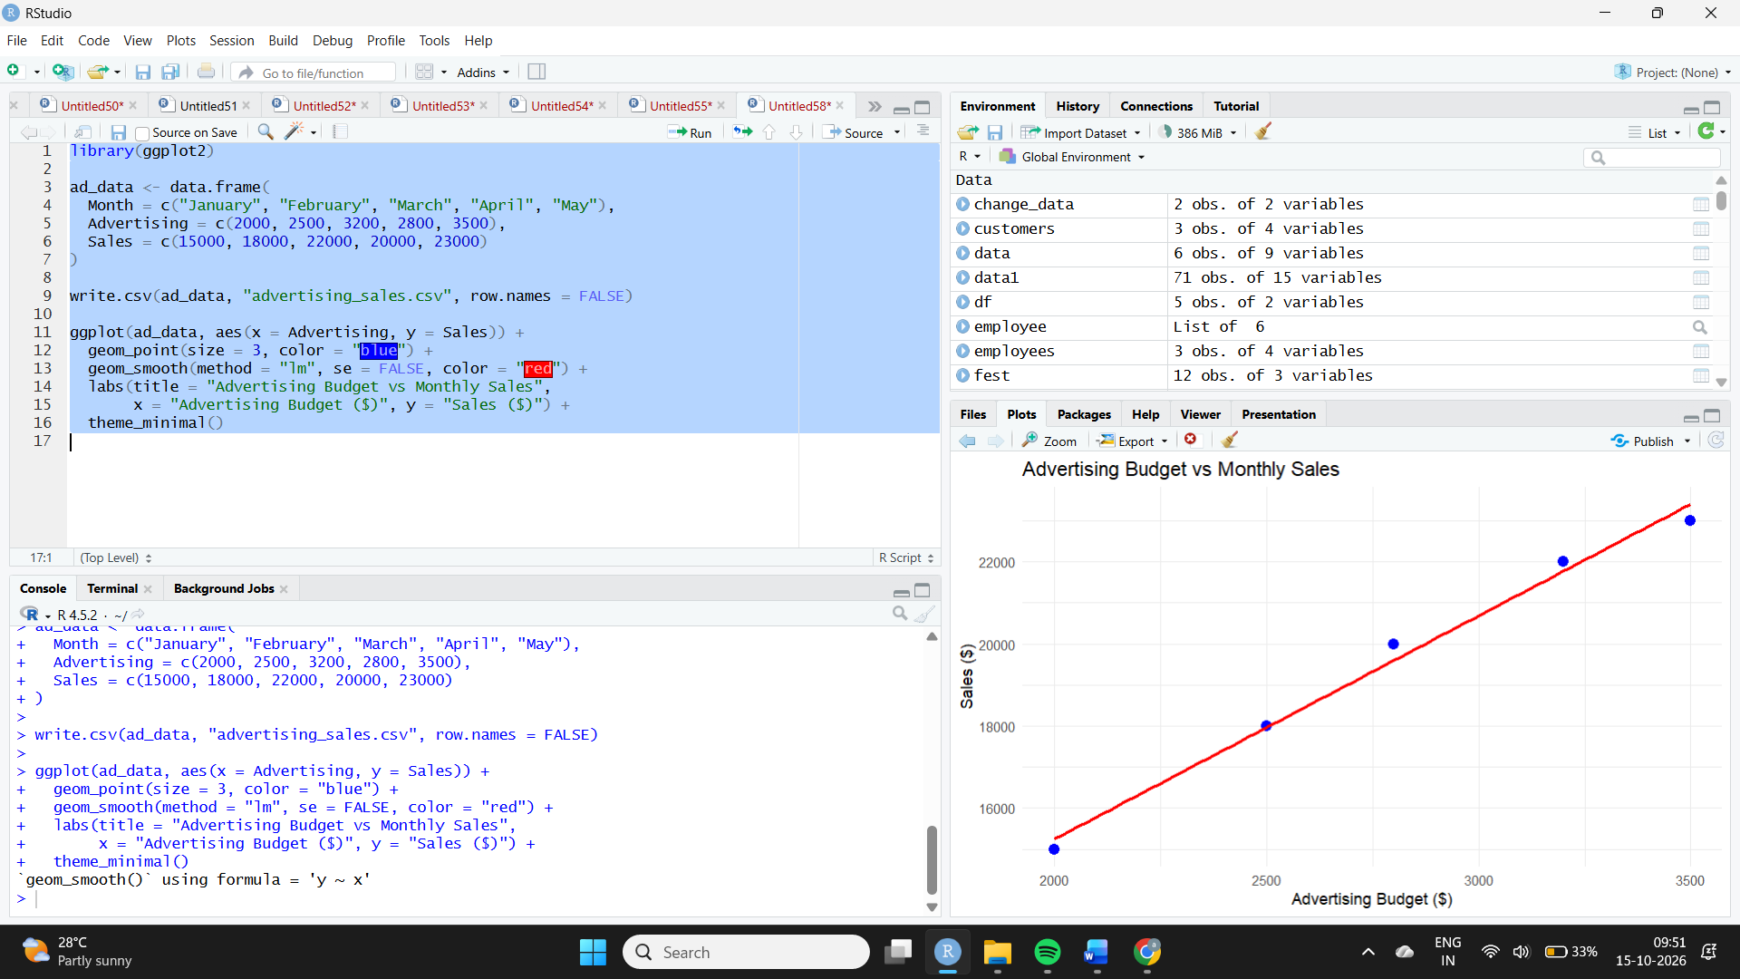
Observation: The illustrative data shows a positive relationship: higher advertising budgets generally correspond to higher sales. The advertising figures are assumed for demonstration because the question does not provide actual advertising budgets. This chart therefore cannot establish the actual relationship from the supplied sales data alone.
3. Tableau dashboard
Aim: To combine a line chart of monthly sales and a pie chart showing sales distribution across products.
Algorithm:
- Import the monthly sales and product sales datasets into Tableau.
- Create a line chart with Month on Columns and Sales on Rows.
- Create a pie chart with Product on Color and Sales on Angle.
- Add both charts to a dashboard and arrange them.
- Add filters if required.
Procedure:
- Connect Tableau to the sales dataset.
- Drag Month to Columns and Sales to Rows; select Line.
- For the pie chart, drag Product to Color and Sales to Angle.
- Create a new dashboard and place both sheets on it.
- Add a title and relevant filters.
Observation: The line chart displays the monthly sales trend. The pie chart compares the proportion contributed by each product. Product-level sales data must be provided to create a meaningful pie chart; the monthly dataset alone is insufficient.
4. Autocorrelation plot
Aim: To examine autocorrelation in monthly sales and investigate possible seasonality.
Algorithm:
- Store the monthly sales values in a time series.
- Generate an autocorrelation function (ACF) plot.
- Examine the correlations at different lags.
- Interpret the results cautiously.
Code:

sales_ts <- ts(c(15000, 18000, 22000, 20000, 23000),
start = c(2025, 1), frequency = 12)

write.csv(data.frame(
Month = c("January", "February", "March", "April", "May"),
Sales = as.numeric(sales_ts)
), "sales_acf_data.csv", row.names = FALSE)

acf(sales_ts, main = "Autocorrelation of Monthly Sales")
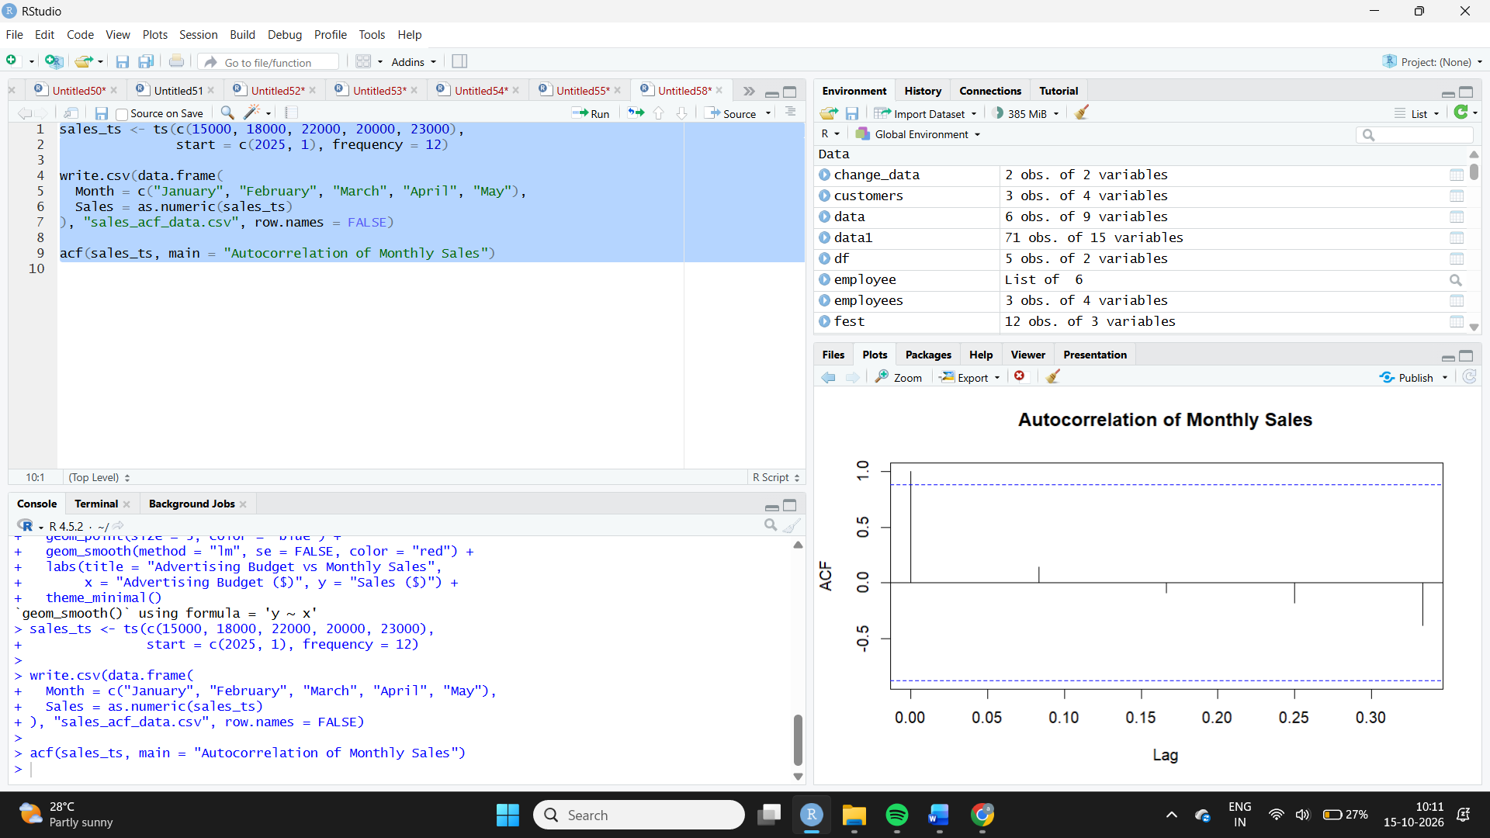
Observation: The ACF plot shows correlations between sales and lagged sales values. However, only five months of data are available, which is insufficient to establish annual seasonality reliably. Several years of monthly observations would be preferable.

